Slay the Spire 2 — Architecture Reference
A deep-reference guide to the structure of this project: what the major
systems are, what they do, and where to find them.

1. Overview
Slay the Spire 2 is a single- and multi-player roguelike deck-building game.
This repository contains a decompiled build of the game running on
Godot 4.6 with game logic written in C# (.NET 9). Godot provides the
scene graph, rendering, windowing and input; nearly all gameplay rules,
content definitions, networking and save logic live in the C# assembly
(sts2).
⚠️ Note on decompiled source. Because the code was reverse-engineered from
a shipped build, you will see compiler-generated artifacts at the repo root
(e.g. --y__InlineArray*.cs, --z__ReadOnly*.cs), .uid sidecar files next
to most assets, and a .autoconverted/ folder of converted GDScript. These
are not hand-written and can largely be ignored when reading gameplay code.
Identifier names in src/ are mostly intact and meaningful.
The mental model is a layered one: Godot nodes render and capture input →
managers (RunManager, CombatManager) drive game flow → state objects
(RunState, CombatState) hold the truth of a run/fight → entities
(Card, Creature, Player) are the live, mutable pieces → models
(ModelDb / AbstractModel) are the immutable data definitions of all content.

2. Technology Stack
Area | Choice | Notes
Engine | Godot 4.6 | Godot SDK 4.5.1; renderer D3D12 on Windows; 2D/3D physics set to "Dummy" (UI-driven game)
Language / Runtime | C# 13 / .NET 9 | Assembly name sts2; Nullable + AllowUnsafeBlocks enabled — see sts2.csproj
SDK pin | .NET SDK 9.0.303 | rollForward: latestMajor — see global.json
Main scene | res://scenes/game.tscn | Defined in project.godot
Autoloads (singletons) | SentryInit, FmodManager | Crash reporting + audio, registered in project.godot
Audio | FMOD (GDExtension 6.1.0) | Banks under banks/desktop/
Networking | Steamworks.NET + ENet | Steam P2P transport with ENet fallback
Runtime patching | 0Harmony (HarmonyLib) | Used by the modding layer
Key NuGet deps | Sentry, SmartFormat, Vortice.DXGI, MonoMod.Backports, JetBrains.Annotations, System.IO.Hashing | See packages.lock.json

Referenced native/managed assemblies live in _mono_referenced_assemblies/
(Steamworks.NET.dll, 0Harmony.dll).

3. Top-Level Directory Map
Path | Role
src/ | All C# source. Core/ is the game; GameInfo/, SourceGeneration/, gdscript/ are support.
scenes/ | Godot .tscn scenes — UI, screens, rooms, VFX, backgrounds. Entry scene is scenes/game.tscn.
shaders/ | .gdshader files — blur, afflictions, card effects, boss highlights, distortions (~46).
animations/ | Spine skeletal animations & spritesheets (.skel + .atlas + .png) per character/background.
materials/ | Godot .tres materials — card banners/frames, outlines, blur masks.
models/ | 3D GLTF assets (minimal — e.g. a power-up mesh).
images/ | Sprite/texture atlases — cards, monsters, relics, potions, orbs, UI, map, characters.
fonts/ | Fonts incl. CJK/localized variants (Kreon, Spectral, Noto Sans CJK, …).
themes/ | Godot theme resources wrapping fonts & UI styling.
localization/ | Per-language text data (15 languages) + completion.json.
banks/ | FMOD audio banks (Master, sfx, ambience, per-act music) under banks/desktop/.
steam/ | Steamworks.NET platform binaries (Windows / OSX-Linux).
addons/ | Godot editor/runtime plugins (see below).
.autoconverted/ | Auto-converted GDScript (.gdc) from the decompile — not primary source.
.godot/ | Godot editor cache/import metadata — generated.
System/, _mono_referenced_assemblies/ | Decompiled BCL stubs and referenced assemblies.
RiderTestRunner/ | JetBrains Rider test-runner scaffolding.

Addons
Addon | Purpose
fmod | FMOD audio engine integration (GDExtension).
sentry | Crash/error reporting (SentryInit autoload).
atlas_generator | Editor tool to build sprite atlases.
dev_tools | In-editor development/debug utilities.
mega_text | Rich text rendering/typography.
megacontentcreator | Content-authoring framework/tooling.
spine | Spine skeletal-animation runtime.

4. High-Level Architecture
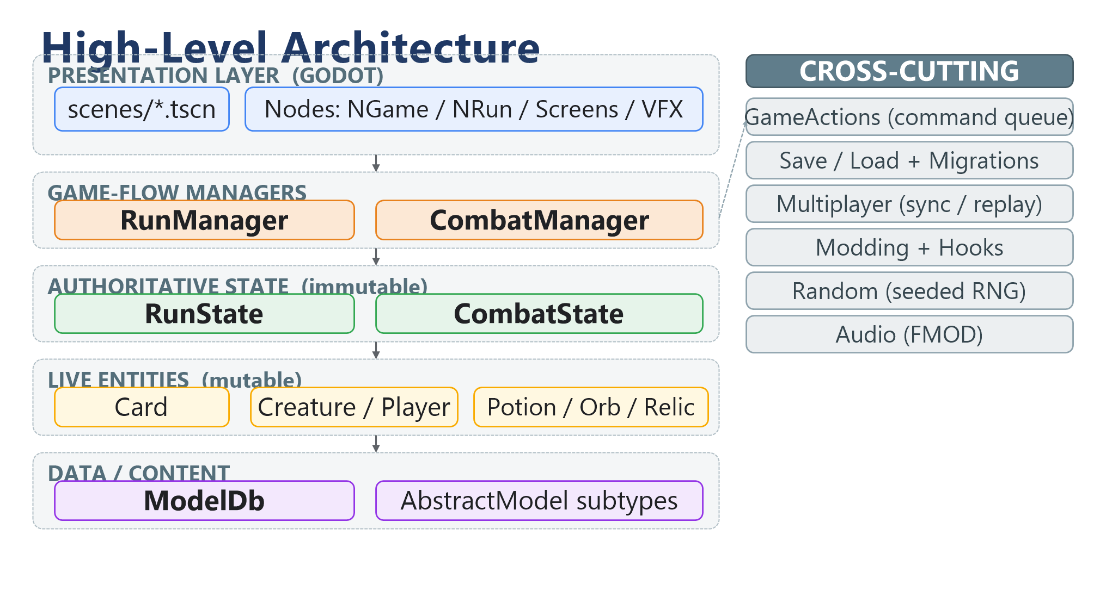
Figure 1 - High-level layered architecture.

5. Core Subsystems
Everything below lives under src/Core/ unless otherwise noted.

5.1 Models / Data Layer — src/Core/Models/
The content database. All game definitions — cards, relics, powers, potions,
enemies, events, acts, and so on — are subclasses of
AbstractModel.cs and registered in the
static registry ModelDb.cs. Each model carries a
unique ModelId (src/Core/Models/ModelId.cs) made of a category + entry key.
Models are effectively immutable data: instances expose AssertMutable()
guards so they cannot be edited at runtime except during controlled
construction/modding.
Discovery is reflection-driven: types are marked with a [GenerateSubtypes]
attribute so the build can enumerate and register every concrete model without
a hand-maintained list — this is what makes the content layer extensible by
mods. Content is organized into per-type folders: Cards/, Relics/,
Powers/, Potions/, Encounters/, Events/, Afflictions/, Acts/,
Monsters/, CardPools/ · RelicPools/ · PotionPools/, Modifiers/
(ascension), Achievements/, Badges/, and Characters/.

5.2 Entities — src/Core/Entities/
The live, mutable counterparts to models. Where a CardModel defines what a
card is, a Card is a specific instance in a deck with current cost, upgrades,
and temporary modifiers. Subfolders:
- Cards/ — Card, PileType (hand/draw/discard/exhaust), TargetType,
CostModifiers, TemporaryCardCost, OrbEvokeType, UnplayableReason.
- Players/ — Player, PlayerCombatState, ExtraPlayerFields.
- Creatures/ — Creature (base for players + monsters), DamageResult, SummonResult.
- Potions/, Orbs/ (Defect-style orb queue), Enchantments/ (card enchant options).

5.3 Combat — src/Core/Combat/
Owns a single fight. CombatManager.cs is the
combat singleton: it drives turn order, executes the action queue, and detects
victory/defeat. CombatState.cs is the immutable
snapshot of the fight (allies, enemies, round number, current CombatSide) and
implements ICardScope. The History/ submodule records timestamped entries
(card drawn, damage received, power applied, …) used for undo, analytics, and
replay.

5.4 Runs / Progression — src/Core/Runs/
Owns an entire run across all acts. RunManager.cs
is the run singleton (transitions, music, achievements);
RunState.cs is the immutable run snapshot (acts,
current map coordinate, players, deck, visited rooms) and implements
IRunState/ICardScope/IPlayerCollection. Card-reward generation
(CardCreationOptions, CardCreationSource, RelicGrabBag), GameMode
(standard/daily/custom), the History/ replay log, and Metrics/
(per-encounter and per-choice statistics) all live here.

5.5 Map — src/Core/Map/
Act-map generation and navigation. ActMap is the abstract base with concrete
strategies StandardActMap, GoldenPathActMap, SpoilsActMap. A map is a graph
of MapPoints (each a MapPointType — monster/elite/treasure/event/rest/merchant
— with a MapPointState) addressed by MapCoord. MapPathPruning removes
unreachable paths after generation.

5.6 Rooms / Encounters — src/Core/Rooms/
A "room" is what you enter when you step on a map node. AbstractRoom is the
base; concrete types are CombatRoom, TreasureRoom, MerchantRoom (shop),
EventRoom (scripted events, may embed combat), RestSiteRoom
(heal/upgrade/smith), and MapRoom (the map-selection screen). RoomType
enumerates them.

5.7 Monster Moves / Enemy AI — src/Core/MonsterMoves/
How enemies decide and telegraph actions. The Intents/ hierarchy
(AbstractIntent → AttackIntent, MultiAttackIntent, BuffIntent,
DebuffIntent, DefendIntent, SummonIntent, EscapeIntent, HealIntent,
typed by IntentType) is the player-visible "what the enemy will do next." A
move state machine (MonsterMoveStateMachine, MoveState,
ConditionalBranchState, RandomBranchState, with MoveRepeatType) sequences
those moves per enemy script.

5.8 Game Actions — src/Core/GameActions/
Turn flow as a command queue. Every discrete game step is a GameAction
subclass — PlayCardAction, EndPlayerTurnAction, UsePotionAction,
PickRelicAction, MoveToMapCoordAction, UndoEndPlayerTurnAction,
ReadyToBeginEnemyTurnAction, etc. An ActionExecutor runs the queue in order.
A Multiplayer/ submodule wraps actions as INetAction for network transport
and handles player-choice resolution and queue synchronization across peers.

5.9 Rewards — src/Core/Rewards/
Post-room loot. Reward is the base; concrete types include CardReward,
SpecialCardReward, CardRemovalReward, RelicReward, PotionReward,
GoldReward. RewardsSet / LinkedRewardSet group multiple rewards shown
together; RewardType enumerates them.

5.10 Events — src/Core/Events/
Scripted narrative encounters. EventOption is a player choice and
EventLayoutType controls presentation. A CustomEvents/ submodule holds
bespoke logic such as the Crystal Sphere minigame. Event definitions live in
src/Core/Models/Events/.

5.11 UI / Nodes — src/Core/Nodes/
The Godot-facing layer; classes here are N*-prefixed nodes that wrap scenes
in scenes/. Top-level entry nodes are NGame.cs
(root game node) and NRun.cs (the run container that
swaps between rooms), plus NSceneContainer and NTransition. Subfolders mirror
gameplay systems: Screens/ (full-screen menus), Combat/, Cards/, Relics/,
Potions/, Orbs/, CommonUi/, HoverTips/, TopBar/, Ftue/
(first-time-user tutorial), Animation/, Audio/, and Pooling/
(object pooling). A large Vfx/-style set of effect nodes (card-fly, damage
numbers, etc.) handles combat juice.

5.12 Save / Load — src/Core/Saves/
Persistence. SaveManager orchestrates saving; SerializableRun is the
JSON-serializable run snapshot. There are separate ProfileSave, SettingsSave,
and PrefsSave types with matching managers, plus CloudSaveStore for cloud
sync and GodotFileIo as the I/O abstraction. A Migrations/ submodule contains
a long chain of versioned upgraders (e.g. SerializableRunV15ToV16) so old saves
load into new builds, alongside custom JSON converters for models/cards/relics.

5.13 Multiplayer — src/Core/Multiplayer/
Full co-op networking. The game runs through a service abstraction —
NetSingleplayerGameService, NetHostGameService, NetClientGameService,
NetReplayGameService — so single-player, host, client, and replay all share one
code path. Transport/ provides the wire (Steam P2P and ENet); Serialization/
has efficient binary PacketWriter/PacketReader plus ModelIdSerializationCache
to compress model IDs; Messages/ defines lobby and in-game message types;
NetMessageBus routes them; CombatStateSynchronizer keeps fights in lock-step;
and Replay/ records and plays back combats.

5.14 Modding & Hooks — src/Core/Modding/ + src/Core/Hooks/
Extensibility without editing source. ModManager discovers and loads mods
(Mod, ModManifest, ModSettings); ModHelper is the public author-facing
API. The Hooks/ system lets mods subscribe to gameplay events (e.g.
ModifyDamageHookType), with GenericHookGameAction firing callbacks inside the
action queue and RunHookSubscriptionDelegate / CombatHookSubscriptionDelegate
defining subscription points. Runtime patching is available via HarmonyLib
(0Harmony).

5.15 Random / RNG — src/Core/Random/
Deterministic, seeded randomness for reproducible runs and fair multiplayer.
RunRngSet holds per-category generators; PlayerRngType and RunRngType
categorize streams (card draw, map gen, rewards, …) so each consumer draws from
an isolated, seeded sequence.

5.16 Audio — src/Core/Audio/
Bridges gameplay to FMOD. FmodSfx triggers sound events; DamageSfxType and
similar enums map gameplay moments to banks. The FmodManager autoload (from the
fmod addon) owns the FMOD system and loads banks from banks/desktop/.

5.17 Supporting Systems
Folder | Role
Achievements/ | Achievement tracking and unlock conditions.
Timeline/ | Story/epoch progression (Stories/, Epochs/) — seasonal/narrative content.
Unlocks/ | Content-unlock gating.
Daily/ | Daily-challenge run generation.
Leaderboard/ | Score/leaderboard submission.
Settings/ | Game settings (aspect ratio, fast mode, …).
Platform/ | Cross-platform abstraction (Steam / desktop).
Localization/ | Runtime string lookup over localization/ data.
ControllerInput/ | Gamepad/controller mapping and navigation.
CardSelection/ | Controller-driven card-targeting/selection logic.
Logging/ | Debug + analytics logging.
DevConsole/ | In-game developer console commands.
Debug/ | Debug overlays and tooling.
AutoSlay/ | Automated/AI play support (likely testing or auto-resolve).
Odds/ | Probability/odds computation for rewards & generation.
Factories/ | CardFactory, RelicFactory, PotionFactory — build entities from models.
Commands/ | Builders for animation/VFX command sequences.
Helpers/ · Extensions/ | Utility methods and LINQ/Godot extension methods.
RichTextTags/ · TextEffects/ | Rich-text formatting and animated text.
HoverTips/ | Tooltip/keyword popup logic.
Context/ | Ambient LocalContext plumbing.
Bindings/ | Spine/MegaSpine animation bindings.
Exceptions/ | Custom exception types.
Assets/ | Asset cache / preload helpers.
TestSupport/ | Test fixtures and harness helpers.

5.18 Non-Core Source
- src/GameInfo/ — CardInfo, RelicInfo, PotionInfo,
EncounterInfo, EventInfo, Keywords — a data-export layer (wikis/tools).
- src/SourceGeneration/ — build-time code generation
(e.g. the [GenerateSubtypes] machinery).
- src/gdscript/ — the C#↔GDScript interop surface.

6. Key Architectural Patterns
- Data-driven content — every game object is an AbstractModel registered in
ModelDb, discovered by reflection via [GenerateSubtypes]. Adding content =
adding a model.
- Immutable state + mutable entities — RunState / CombatState are
immutable snapshots; Card / Creature / Player are mutated in place.
- Command pattern — all turn actions are GameActions run by an
ActionExecutor; this enables ordering, undo, and network serialization.
- Hook/event modding — mods inject behavior by subscribing to typed hooks
rather than patching (Harmony available for deeper patches).
- Factory pattern — *Factory classes instantiate entities from models.
- History / replay — CombatHistory and RunHistory log timestamped
entries; Replay/ reconstructs fights.
- Save migrations — a versioned Migrations/ chain keeps old saves loadable.
- Network state synchronization — one Net*GameService abstraction with
compact binary packets and a combat synchronizer keeps peers deterministic.
- Godot signal-based async — UI awaits Godot signals via extension helpers.
- Object pooling — Nodes/Pooling/ reuses heavy UI/VFX nodes.

7. Entry Points & Central Singletons
Symbol | File | Role
scenes/game.tscn | scenes/game.tscn | Godot main scene; boots the game.
NGame | src/Core/Nodes/NGame.cs | Root game node.
NRun | src/Core/Nodes/NRun.cs | Run container; swaps rooms/screens.
RunManager.Instance | src/Core/Runs/RunManager.cs | Run lifecycle singleton.
CombatManager.Instance | src/Core/Combat/CombatManager.cs | Combat lifecycle singleton.
RunState | src/Core/Runs/RunState.cs | Immutable run truth.
CombatState | src/Core/Combat/CombatState.cs | Immutable combat truth.
ModelDb | src/Core/Models/ModelDb.cs | Static content registry.
FmodManager (autoload) | addons/fmod/FmodManager.gd | Audio system.
SentryInit (autoload) | addons/sentry/SentryInit.gd | Crash reporting.

8. Gameplay Loop
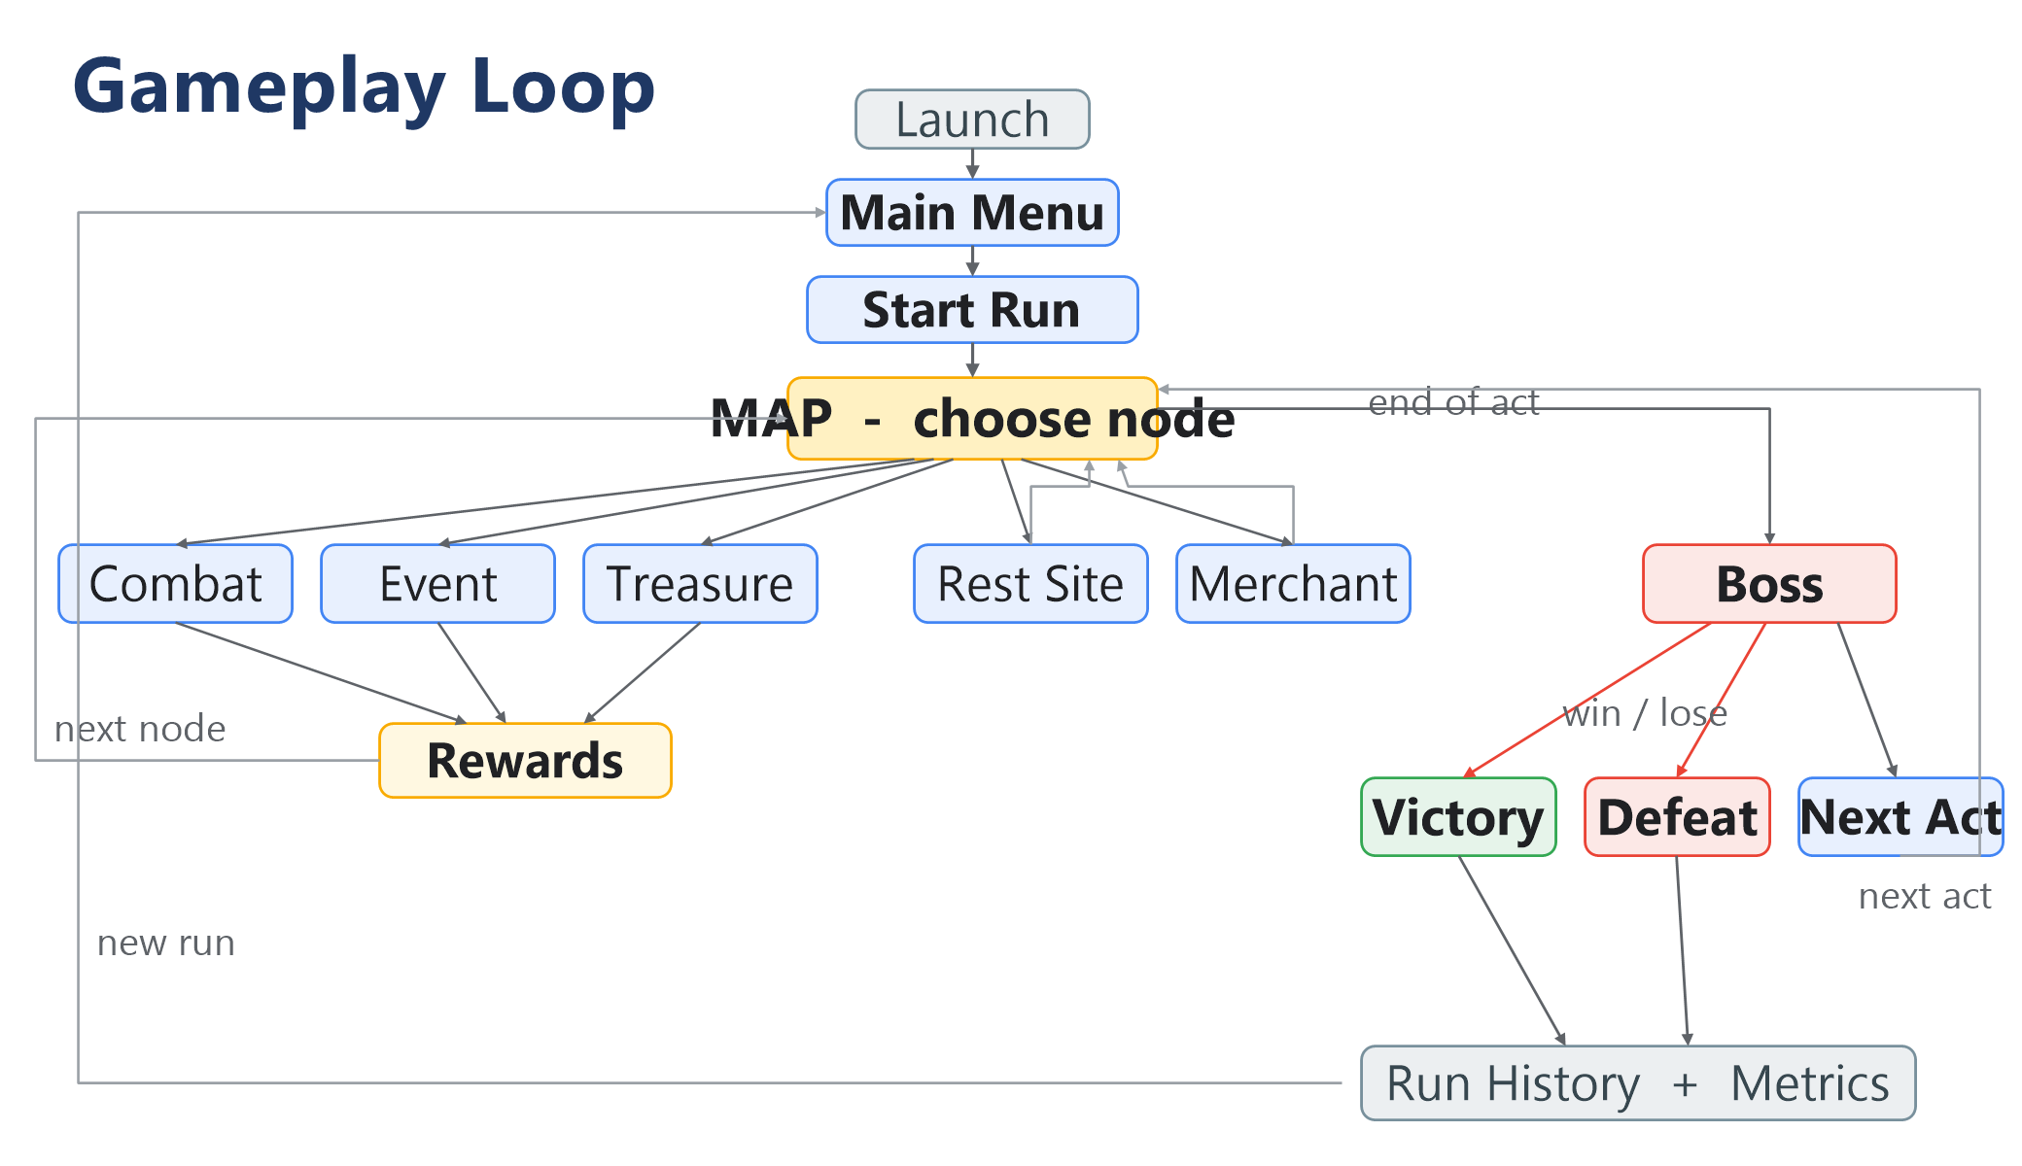
Figure 2 - The per-run gameplay loop.

*Generated as an onboarding reference. Paths point at the decompiled C# source
under src/Core/; diagrams render on GitHub and in any Mermaid-aware
Markdown viewer.*

